Welcome!
Date
Name
Spouse
Address
City
State Zip _________
Email

Please Contact By
❑ Card  Phone  Visit

Telephone Best Time to Call
Home ______________
Work ______________

Guest: First Time Second Time
Are you a church member: yes no
Church
City, State

Circle Appropriate Age/Grade Group(s)
Preschool: Ages: B-1 2-3 4-5
Children: Grades: K 1 2 3 4 5 6
Youth: Grades: 7 8 9 10 11 12
Adults: Ages:18-29 30s 40s 50s 60s+

How did you learn about our church?
Newspaper Friend Yellow Pages Mail
Other

I am a guest of:

New in the Community? Yes No
Names & ages of children at home

Weekly Service & Activity Schedule

Jan 14, 2018

9:45 a.m. Sunday School
11:00 a.m. Worship Service
6:00 p.m. Evening Service/Business Meeting

Week of Jan 14, 2018
Wednesday 6:30 pm……………..……….Meal/Bible Study
Friday 6:30 pm……………….…………..Men’s 42 Night

January
New Commandment Kids will not meet for the month of January
18………..….Assoc. Annual Fish Fry/FBC Somerville
February
4………………………………New Commandment Kids
11……………………………..New Commandment Kids
11………………………….………Valentine’s Luncheon

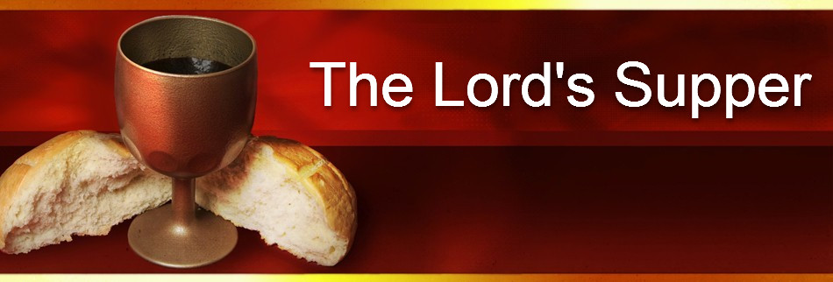

Come with hearts prepared

Prayer for In Dec 3-17

Tonight after the evening service

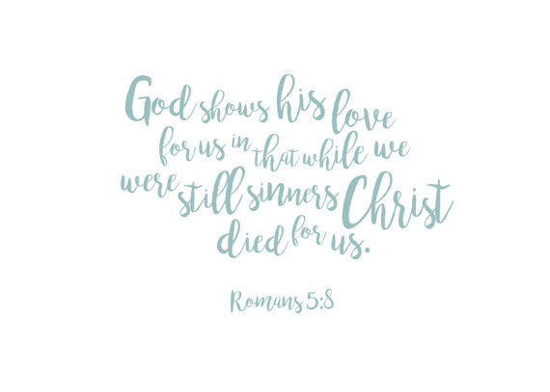

Knobbs Springs Baptist Church

Jan 14, 2018

Church Information:

KnobbsSpringsBC.com KnobbsSpringsBaptist@gmail.com

1662 CR 305, McDade, Texas 78650 512-273-2743

David Atwood, Pastor Cell 512-470-5098

Patti Radford, Office Manager Cell 512-968-7821

